Chemical Results from the April 2007 NPEO Project
Water sampling procedure
A delay of seven days from the intended start date (April 14) occurred due to persistent high winds (~50 knots) at the Borneo Ice Camp (~89ºN, 0ºE) that literally broke the runway. Despite this delay, ten stations were sampled between April 21 and 29 along two transects that intersected with the North Pole (Fig. 1).

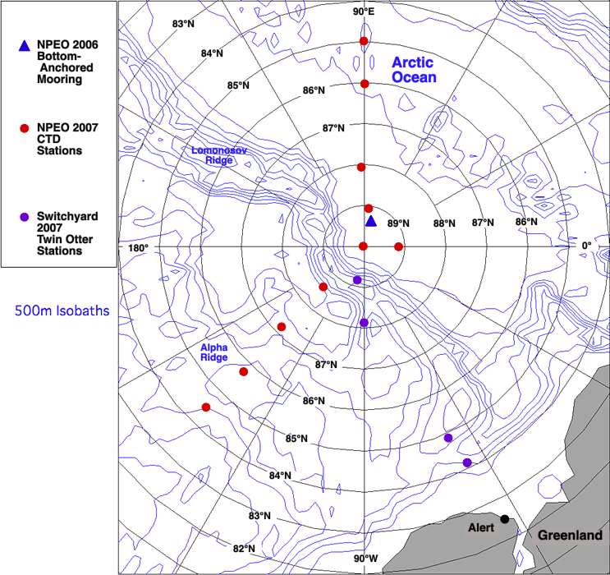
Figure 1. Locations of North Pole Environmental Observatory hydrographic stations as well as Switchyard stations during the 2007 field program.

Note the entire 135ºW line and station 85ºN, 90ºE have never previously been sampled during the NPEO program. At all stations, casts included both Seabird SBE19 plus (2737) CTD-O₂ (equipped with a Seabird SBE SBE 43 O₂ sensor) and Satlantic (MBARI, model V2) ISUS (in-situ ultraviolet spectrophotometer) internally recording packages. In addition, water samples were collected from target depths (20, 60, 80, 100, and 120 meters) at all stations except Borneo. An additional deep sample (~300 m) was collected at selected stations: 85ºN, 90ºE, 86ºN, 90ºE, and the North Pole.

Robert Collier, Jamie Morison, and Matthew Alkire carried out the fieldwork with assistance from First Air pilot Troy McKerral, co-pilot Travis Goatzinger and engineer Mike McCrae. The Russian ice camp Borneo served as the base camp and Andy Heiberg coordinated logistics.

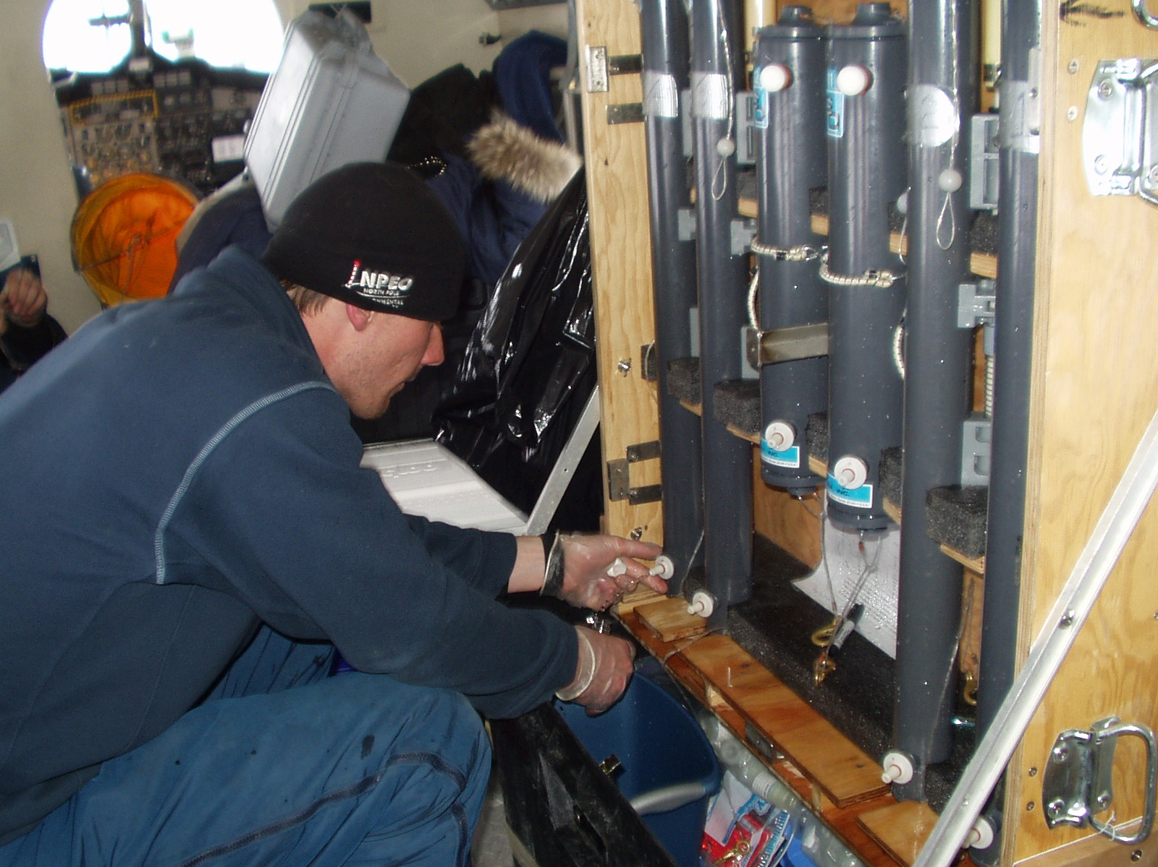

Matthew Alkire draws water samples from the Niskin bottle rack in the airplane.

Generally, the casts were made through fairly smooth, snow covered ice that was 2-3 m thick. Ice conditions are of course selected for suitability of landing the aircraft and expediency of science operations so they are not necessarily representative.
Cast were made using the generator-powered portable winch. Five custom constructed Niskins (three General Oceanics model 1010 with 8" extension 1.5-L, and two General Oceanics model 1010 1.2-L all with modified plunger heads and short-handled end-caps) were mounted on a small diameter Kevlar line, with the deepest one mounted about 1 meter above the ISUS. The CTD-O₂ system was placed directly beneath the ISUS package. Upon lowering the shallowest bottle to 20 m and soaking for 5 minutes, a stainless steel messenger was released. Upon retrieval, each Niskin was transferred to a rack in the heated aircraft and samples were drawn immediately. Dissolved oxygen samples were carefully drawn into 125 ml calibrated flasks and reagents added immediately to fix O₂ and the flasks stoppered. Distilled water was added around the top of the stopper and then the tops of the flasks were sealed with parafilm. Salinity samples were collected into 125-ml glass bottles, the caps of which were fitted with conical polyethylene inserts, and parafilmed. Oxygen isotope samples were collected into similar containers of smaller volume (20-ml). Barium samples were collected into precleaned 20-ml polyethylene bottles. Nutrient samples were collected into precleaned 60-ml polyethylene bottles and stored frozen. Samples for total alkalinity were collected into precleaned 20-ml polyethylene bottles. Random replicates were drawn for each parameter throughout the field program.

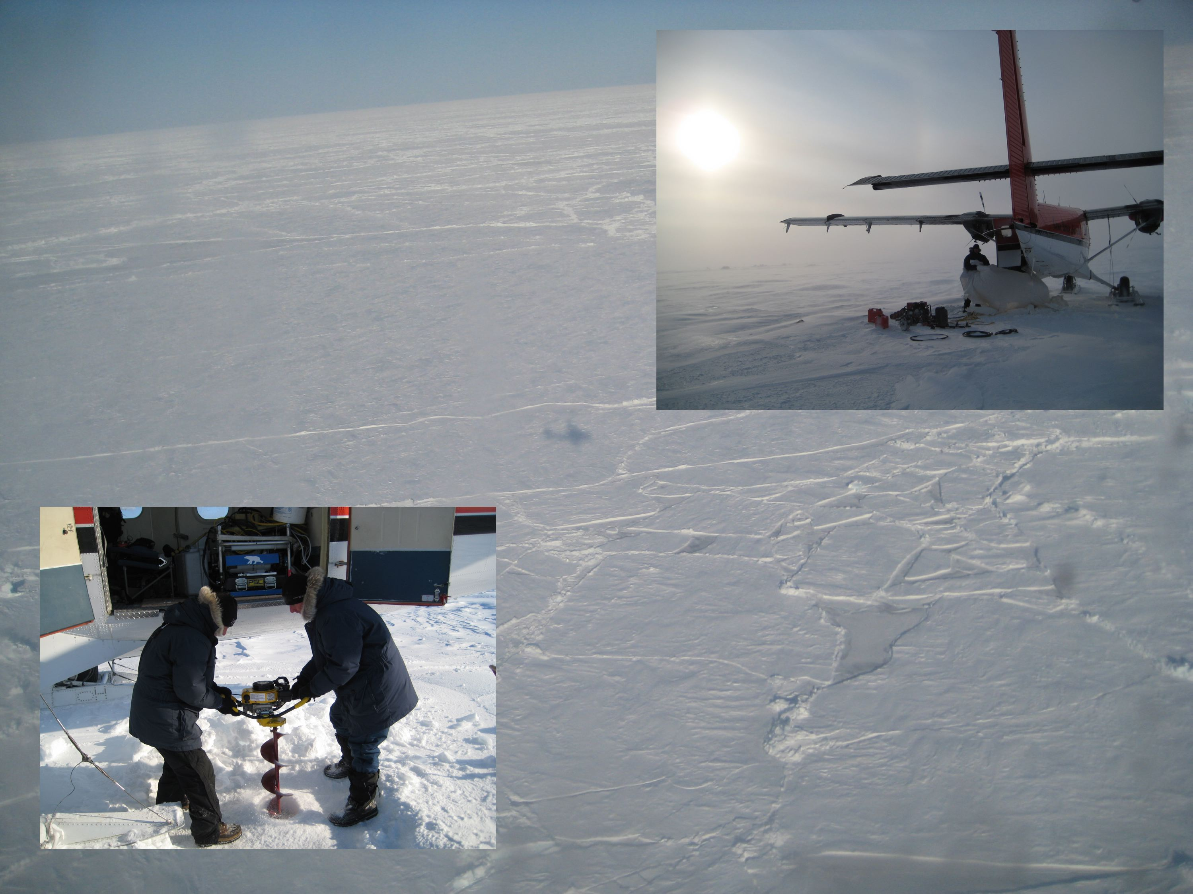

At station 86ºN, 90ºE there was immense difficulty in recovering the cast due to high winds that resulted in a very fast drift of the ice floe. This motion resulted in a large angle in the line, such that a groove was cut into the ice by the wire, preventing the entire line from being recovered. A second hole had to be drilled in the ice and an approximately four-meter length rod, fastened at the end with a clip, was improvised to hook the line and pull it into the enlarged hole. The initial release of the messenger did not trip the bottles because it was stuck at the bottom of the ice within the freshly cut groove. The cast was subsequently brought up and the top (initial target depth 20m) bottle was tripped by hitting the bottom of the ice! As a result, 20 meters was subtracted from all target depths to arrive at new expected depths. Thus, the original target depths 20, 60, 80, 100, 120, and 300 meters became 0, 40, 60, 80, 100, 280 meters, respectively.

Analytical procedures
The data are reported in Table 1 along with the standard deviation for replicate samples. The latter are denoted by the “unc” abbreviation for uncertainty in the table and are in reasonable accord with uncertainty estimates based on longer term measurement assessments as discussed below. Bottle salinities were analyzed at Alert using a model 8400A Guildline Autosal standardized with IAPSO standard seawater. The estimated uncertainty in bottle salinity determinations was ± 0.005 (pooled standard deviation from four field duplicates). Analyses of the frozen phosphate, silicic acid, nitrate, nitrite and ammonia samples were performed at OSU using a hybrid Alpkem RFA 300 and Technicon AA-II (AutoAnalyzer II) — based system and the JGOFS/WOCE suggested nutrient protocols (Gordon et al., 1994). The silicic acid, nitrate plus nitrite and nitrite channels were RFA-based, the phosphate and ammonium channels, AA-II. The samples were thawed and analyzed within 2 hours for all nutrients. After standing 48 hr in the dark, the samples were reanalyzed for silicic acid to resolve polymerization effects (Gordon et al., 1994). The short-term precision of the nutrient analyses is typically: Silicic acid, 0.2%; phosphate, 0.4%; nitrate 0.3%; nitrite, 0.02µM; and ammonium, 0.03µM. However, the inter-cruise reproducibility achieved during the WOCE Hydrographic Program, Pacific One-Time Survey was for silicic acid, phosphate and nitrate, respectively, ca. 1%, 2% and 1% (unpublished data, Andrew Ross, personal communication).
Barium was determined by isotope-dilution using an VG Thermo Excel inductively coupled quadrupole mass spectrometer as previously described with minor modifications (Falkner et al., 1994). Precision is estimated to be ≤2% at the measured Ba concentration. Archived spiked GEOSECS samples were run to assure consistency with historical results.
Total alkalinity was determined according to the method of Dickson et al. (2003) with a few deviations. First, due to the limited volume of the modified Niskin bottles, 15-20 mL were acquired for running total alkalinity as opposed to between 50 and 125 mL typical of the reported method. Furthermore, samples were not poisoned with HgCl₂ after collection, although the low productivity (9-57 mg C m⁻² day⁻¹, Gosselin et al., 1997) as well as the lack of CaCO₃-bearing organisms in central Arctic waters (Anderson et al., 2004) suggests that sample poisoning may not be entirely necessary. Estimates of precision based on field duplicates (n=2) yielded values of ± 2-4 µmol kg⁻¹. Furthermore, an estimate of the accuracy was obtained by running a certified reference material seawater prepared by Andrew Dickson (http://andrew.ucsd.edu/co2qc/). The reported value for the total alkalinity of this seawater is 2214.49 ± 0.44 µmol kg⁻¹. Numerous runs (n=8) conducted on this seawater yielded an average (± stdev) of 2215 ± 4 µmol kg⁻¹.
Oxygen isotope measurements on the water samples have yet to be completed at the time of this posting as the analytical facility at OSU is undergoing renovation.
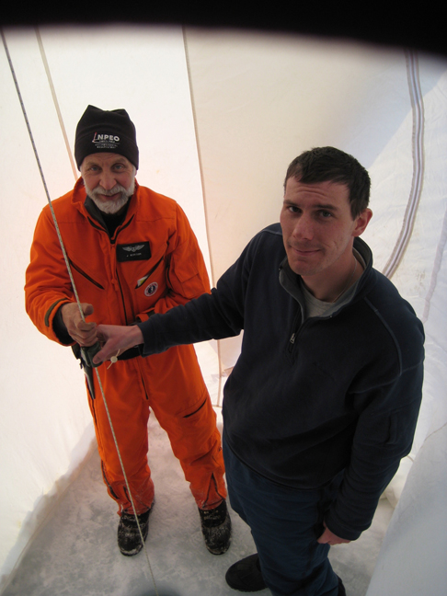
Jamie Morison and Matthew Alkire drop the messenger to trip the Niskin bottles.

The CTD properties were assigned to individual Niskin bottles by matching the bottle salinities to a linearly interpolated downcast CTD salinity nearest the target depth. Note that for stations 85ºN, 90ºE and 86ºN, 90ºE bottle salinities are matched to the first downcast (only available cast) whereas the remaining stations were matched to the second downcast, on which the bottles were hung. The match is identified by finding the minimum difference between the bottle salinity and the CTD data. Specifically, we have devised a Matlab code that searches for the two points for which the difference between the bottle salinity and the CTD salinity change from a positive to negative difference or vice versa. Once these points have been identified, a linear interpolation between the points to match the bottle salinity is taken to calculate the true depth and in-situ temperature. Typically, true depths match target depths within ± 2 meters; however, some problems were encountered in matching these depths using bottle salinities. Out of the nine stations where samples were collected from a target depth of 20 meters, eight had bottle salinities greater than CTD salinities near the target depth. Bottle salinities exceeded CTD salinities by 0.001-0.009 at seven of these stations. At one station (89ºN, 90ºE) the bottle salinity was 0.17 greater than that expected from the CTD but this bottle was noted to have failed the leak check completed upon retrieving the bottle.
Due to the fact that the 20 m bottles do not traverse as much of the water column as deeper bottles during the descent and is allowed the shortest flushing time (~5 minutes after it is in place), it is possible that flushing is not complete when the bottles are tripped. This results in the most time for re-freezing to occur within the ice hole as well as both the least time and volume of water allowed to flush the bottle. This effect has been observed repeatedly throughout the NPEO project. It is clear from an examination of the various station conductivity-based salinity profiles (not shown) that there is some signal from the hole in the topmost water column. In 2005, the soaking time was increased from one to five minutes to ameliorate this problem. The 2006 and 2007 field deployments results suggest, however, that more time might be needed to allow complete flushing at the 20 m depth. It is also possible that leaks can result in contamination of bottles while they are brought back up through the ice hole. Such leaks might occur due to bottle failure or perhaps from hitting or scraping the bottom of the ice before entering the hole.
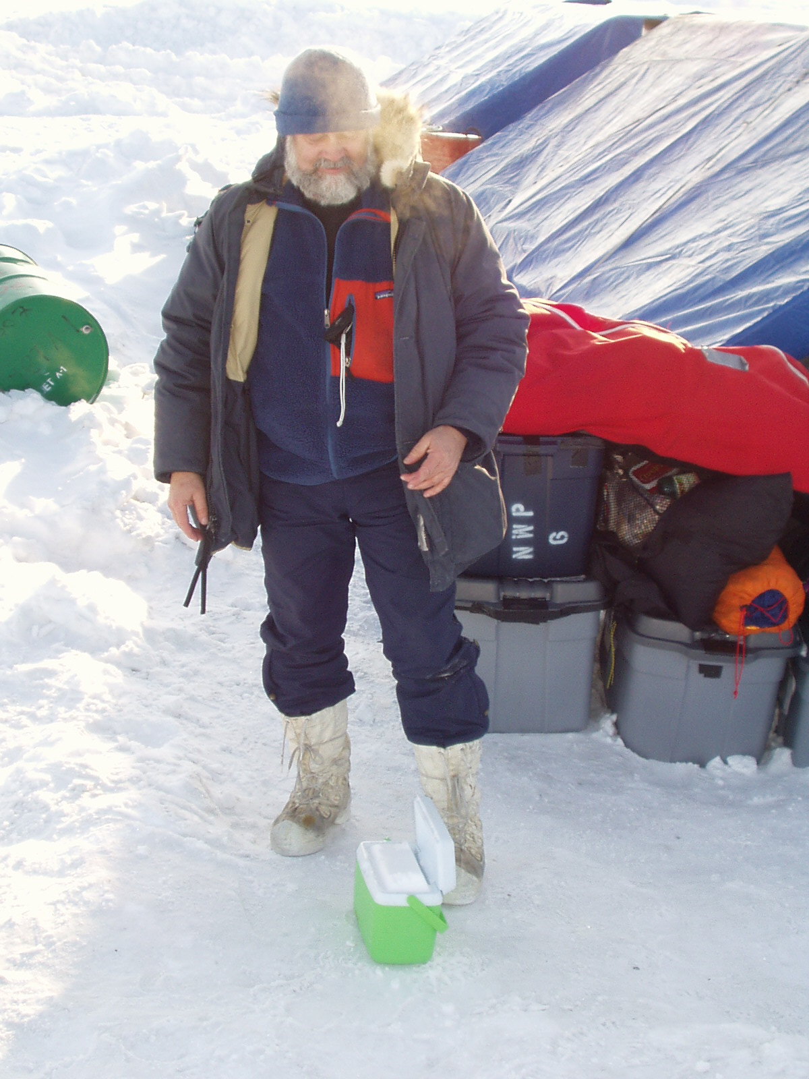
Bob Collier checks to make sure the nutrient samples are frozen.

As a result of these complications, where the salinity-matching code produced an obviously bad result (or no result at all), a depth was assigned by examining the CTD depth/pressure record versus scan count and calculating approximate bottle positions from plateaus in depth. Salinities were then assigned according to these depths.

Results
The repositioning of the Atlantic-Pacific front back towards the Mendeleev-Alpha Ridge, indicated in 2006 observations (Alkire et al., 2007), was similarly observed in 2007. There was no significant contribution of Pacific water in the samples collected at the North Pole station. Pacific fractions ≥ 27% were limited to the ~135ºW line. Fractions were highest at 84ºN and decreased both northward and vertically downward. The 84ºN,135ºW station illustrated the most pronounced Pacific influence with fractions exceeding 80% throughout the top 120 meters of the water column and clear potential temperature maxima and minima indicative of Alaskan Coastal Water (ACW), summer Bering Seawater (sBSW), and winter Bering seawater (wBSW) (see CTD data archived at http://psc.apl.washington.edu/northpole/). Silicic acid concentrations were also highest at this station (≥ 35μM) at depths 100-120 meters, which is characteristic of wBSW. Silicic acid was also elevated (23μM) at ~100 meters depth at station 86ºN, 135ºW and N:P relationships indicate that sample was composed of 49% Pacific water. Pacific fractions and silicic acid concentrations were lower at stations 87 and 89ºN along the 135ºW line, suggesting a northward decrease in Pacific influence consistent with a migration of the Atlantic-Pacific front towards its location during the early 1990s. Potential temperature signatures of Pacific-influenced halocline waters were located shallower in the water column at station 86 (absent at 87 and 89) relative to 84ºN. These observations suggest lighter, Pacific-influenced waters displaced Atlantic-influenced halocline waters to a lesser extent in the northern reaches of the central Arctic during this time. Relatively high (≥ 10μM) silicic acid concentrations, linked to the presence of wBSW, followed a similar trend as the magnitude and depth of occurrence decreased northward from 84 to 89ºN.

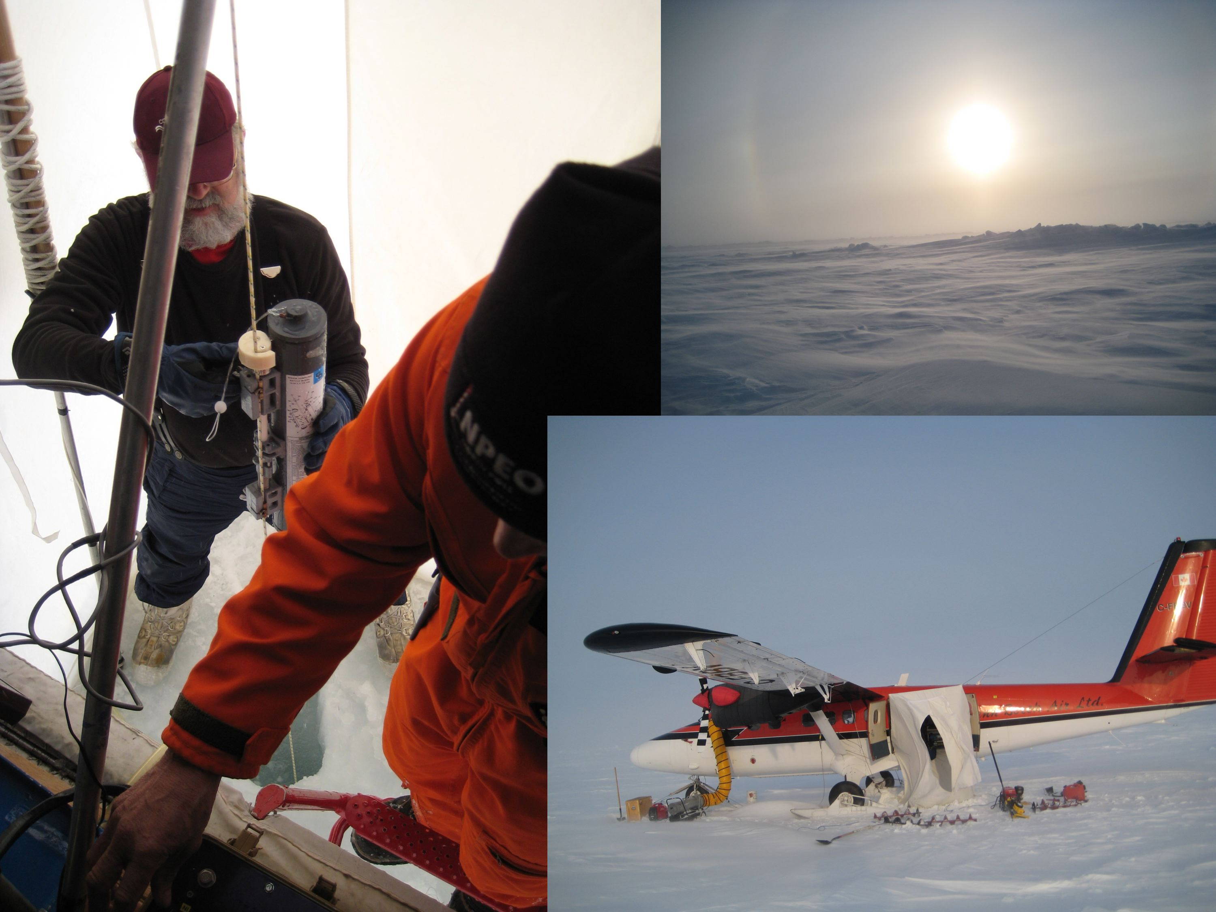

Barium concentrations were highest at station 84ºN, 135ºW and remained at ~60nM along the 135ºW line. With the exception of the very high barium concentration (134nM) measured in the 20 meter sample at 84ºN, 135ºW (which is suggestive of an influence from Mackenzie River water; Guay and Falkner, 1997), barium concentrations were significantly and positively correlated (R²=0.63) with Pacific influence along the 135ºW line. These results suggest the high barium concentrations were due to Pacific input and Pacific-derived shelf waters. An initial mass balance calculation incorporating salinity, barium, and total alkalinity data and utilizing endmembers specified by Yamamoto-Kawaii et al. (2005) supported this speculation. North American river water had significant influence only at station 84ºN, 135ºW where barium concentrations were ≥75nM. .

The distribution of total alkalinities mirrored that of both Pacific fractions and barium concentrations. The lowest total alkalinities (< 2260μmol kg⁻¹) were confined to the 135ºW line; however, the North Pole station maintained low total alkalinities (< 2270 μmol kg⁻¹) to ~80 meters depth. The highest total alkalinities were observed along the 90º line; however, indications of Siberian river water influence were evidenced by slightly lower total alkalinities coincident with higher (≥ 50nM) barium concentrations.

References
Alkire, M.B., Falkner, K.K., Steele, M., Rigor, I., Morison, J., 2007. The return of Pacific waters to the upper layers of the central Arctic Ocean, Deep-Sea Research I 54, 1509-1529.
Anderson, L.G., Jutterstroem, S., Kaltin, S., Jones, E.P., Bjoerk, F., 2004. Variability in river runoff distribution in the Eurasian Basin of the Arctic Ocean, Journal of Geophysical Research 109, doi:10.1029/2003JC001773.
Dickson, A.G., Afghan, J. D., Anderson, G. C., 2003. Reference materials for oceanic CO₂ analysis: A method for the certification of total alkalinity. Marine Chemistry 80, 185-197.
Falkner, K.K., R.W. MacDonald, E.C. Carmack, and T. Weingartner, 1994. The potential of barium as a tracer of Arctic water masses, in The Polar Oceans and Their Role in Shaping the Global Environment: The Nansen Centennial Volume, AGU Geophys. Monograph Series, edited by O.M. Johannessen, R.D. Muench, and J.E. Overland, pp. 63-76, AGU Books, Washington DC.
Gordon, L.I., J.J.C. Jr., A.A. Ross, and J.M. Krest, A suggested protocol for continuous flow automated analysis of seawater nutrients (phosphate, nitrate, nitrite and silicic acid) in the WOCE Hydrographic Program and the Joint Global Ocean Fluxes Study. WOCE Operations Manual, Vol. 3: The Observational Program, Section 3.1: WOCE Hydrographic Program, Part 3.1.3: WHP Operations and Methods., pp. 52 loose-leaf, Woods Hole, Mass., 1994.
Gosselin, M., Levasseur, M., Wheeler, P.A., Horner, R.A., Booth, B.C., 1997. New measurements of phytoplankton and ice algal production in the Arctic Ocean, Deep-Sea Research II 44, 1623-1644.
Guay, C.K., Falkner, K.K., 1997. Barium as a tracer of Arctic halocline and river waters, Deep-Sea Research II 44, 1543-1569.
Jakobsson, M.N.Z., N.Z. Cherkis, J. Woodward, R. Macnab, and C. B., New grid of Arctic bathymetry aids scientists and mapmakers, EOS, Transactions, American Geophysical Union, 81 (9), 2000.
Yamamoto-Kawai, M., Tanaka, N., 2005. Freshwater and brine behaviors in the Arctic Ocean deduced from historical data of δ¹⁸O and alkalinity (1929-2002 A.D.), Journal of Geophysical Research 110, doi:10.1029/2004JC002793.

Acknowledgements
M. Alkire and R. Collier wish to acknowledge laboratory assistance from Bill Rugh, Andy Ross, and Joe Jennings of OSU as well as Robert Williams from Scripps Institute of Oceanography and Bill Smethie of Lamont Doherty Earth Observatory. The First Air crew, pilot Troy McKerral, co-pilot Travis Goatzinger and engineer Mike McCrae contributed well above and beyond the call of duty to the sampling effort. They did this despite challenging living conditions and fuel availibility issues at Borneo. Colleagues Roger Anderson, Andy Heiberg, and Jamie Morison are thanked for their stalwart efforts in the field and behind the desk. Financial support was provided by the National Science Foundation under grants OPP-9910335 and OPP-0352984. Any opinions, findings, and conclusions or recommendations expressed in this material are those of the author(s) and do not necessarily reflect the views of the National Science Foundation.

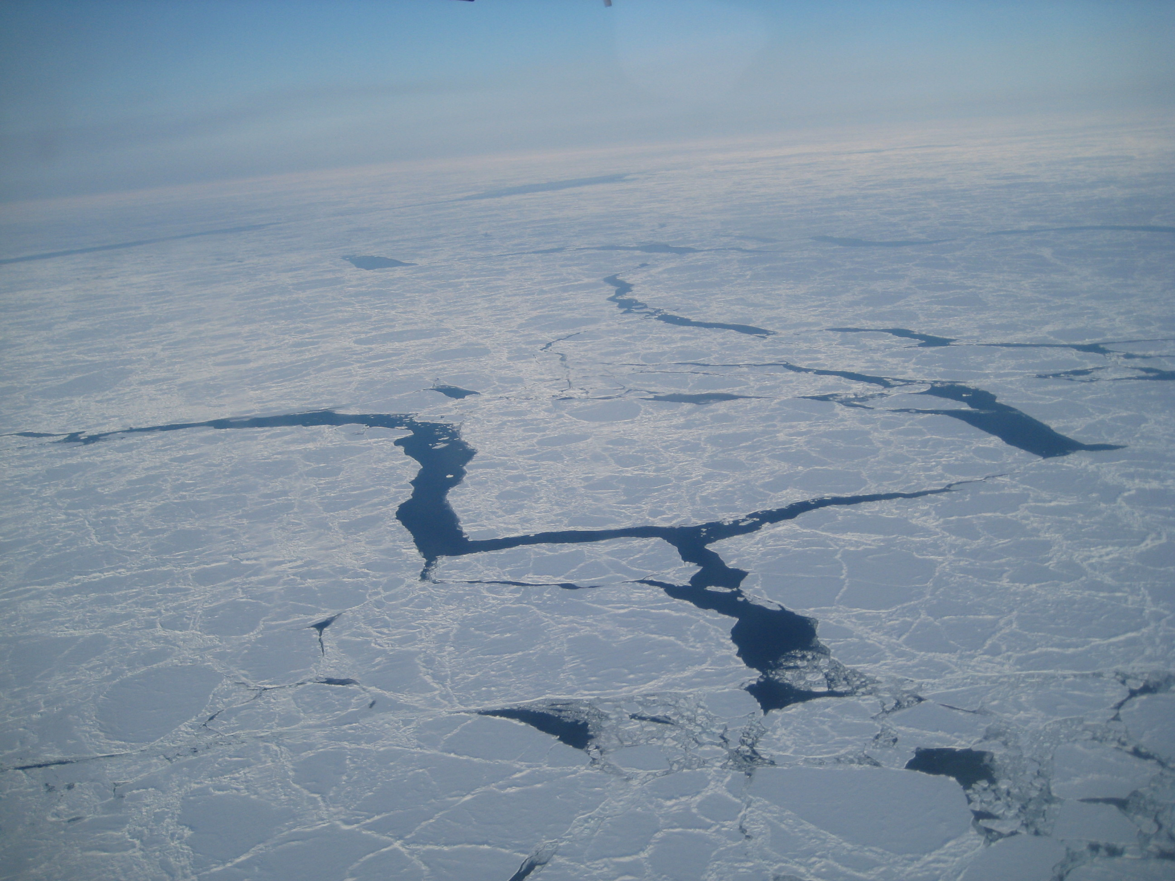
The break up of the ice pack seen while flying the airplane to the next station.

 |  |  | CTD Data
Station | Cast | Latitude | Longitude | Date | CTD On | Target | Depth | Press
 |  |  |  |  | UTC | Depth
 | No. |  |  |  | hh:mm:ss | m | m | dbar
85N,90E | 1 | 84.98 | 90.34 | 4/22/2007 | 1:28:00 | 20 | 20.91 | 21.15
 |  |  |  |  |  | 60 | 61.23 | 61.93
 |  |  |  |  |  | 80 | 80.16 | 81.08
 |  |  |  |  |  | 100 | 99.92 | 101.07
 |  |  |  |  |  | 120 | 122.73 | 124.15
 |  |  |  |  |  | 300 | 301.67 | 305.27
86N,90E | 1 | 86.03 | 90.08 | 4/23/2007 | 16:38:27 | 0 | 1.50 | 1.52
 |  |  |  |  |  | 40 | 39.48 | 39.93
 |  |  |  |  |  | 60 | 57.81 | 58.47
 |  |  |  |  |  | 80 | 76.44 | 77.31
 |  |  |  |  |  | 100 | 97.52 | 98.64
 |  |  |  |  |  | 280 | 270.51 | 273.73
88N,92E | 2 | 88.06 | 92.63 | 4/23/2007 | 22:28:08 | 20 | 21.23 | 21.47
 |  |  |  |  |  | 60 | 59.07 | 59.74
 |  |  |  |  |  | 80 | 81.76 | 82.70
 |  |  |  |  |  | 100 | 101.38 | 102.55
89,90E | 2 | 89.06 | 84.49 | 4/28/2007 | 0:38:32 | 20 | 21.60 | 21.85
 |  |  |  |  |  | 60 | 61.98 | 62.69
 |  |  |  |  |  | 80 | 82.71 | 83.66
 |  |  |  |  |  | 100 | 101.05 | 102.21
 |  |  |  |  |  | 120 | 119.38 | 120.76
84N,135W | 2 | 84.48 | -134.71 | 4/24/2007 | 20:57:10 | 20 | 20.93 | 21.17
 |  |  |  |  |  | 60 | 60.65 | 61.34
 |  |  |  |  |  | 100 | 100.42 | 101.57
 |  |  |  |  |  | 120 | 120.48 | 121.87
86N,135W | 2 | 85.74 | -134.15 | 4/25/2007 | 1:22:55 | 20 | 20.96 | 21.20
 |  |  |  |  |  | 60 | 61.67 | 62.37
 |  |  |  |  |  | 100 | 101.54 | 102.71
 |  |  |  |  |  | 120 | 121.55 | 122.95
87N,135W | 2 | 87.17 | -136.18 | 4/28/2007 | 16:18:17 | 20 | 21.09 | 21.33
 |  |  |  |  |  | 60 | 61.07 | 61.77
 |  |  |  |  |  | 80 | 80.88 | 81.81
 |  |  |  |  |  | 100 | 101.08 | 102.24
 |  |  |  |  |  | 120 | 120.36 | 121.75
89N,135W | 2 | 88.58 | -136.03 | 4/28/2007 | 20:15:17 | 20 | 21.71 | 21.96
 |  |  |  |  |  | 60 | 59.41 | 60.09
 |  |  |  |  |  | 80 | 80.23 | 81.15
 |  |  |  |  |  | 100 | 101.57 | 102.74
 |  |  |  |  |  | 120 | 121.89 | 123.30
NP | 2 | 89.96 | 169.12 | 4/25/2007 | 20:14:50 | 20 | 21.84 | 22.09
 |  |  |  |  |  | 60 | 59.48 | 60.16
 |  |  |  |  |  | 80 | 80.43 | 81.35
 |  |  |  |  |  | 100 | 101.68 | 102.85
 |  |  |  |  |  | 120 | 120.58 | 121.98
 |  |  |  |  |  | 300 | 298.92 | 302.50

 |  |  | CTD Data
Station | Target | In-situ T90 | Pot T90 | Cond | Salinity | Density
 | Depth
 | m | degC | degC | S/m | psu | sigma-theta
85N,90E | 20 | -1.8490 | -1.8494 | 2.6677 | 33.8886 | 27.2786
 | 60 | -1.8481 | -1.8492 | 2.6698 | 33.8910 | 27.2805
 | 80 | -1.5126 | -1.5144 | 2.7138 | 34.1057 | 27.4459
 | 100 | -1.0146 | -1.0173 | 2.7702 | 34.2992 | 27.5861
 | 120 | -0.2194 | -0.2236 | 2.8475 | 34.4251 | 27.6535
 | 300 | 1.2199 | 1.2051 | 3.0125 | 34.8605 | 27.9194
86N,90E | 20 | -1.8328 | -1.8328 | 2.6382 | 33.4706 | 26.9377
 | 60 | -1.8278 | -1.8285 | 2.6403 | 33.4661 | 26.9376
 | 80 | -1.7103 | -1.7114 | 2.6658 | 33.6785 | 27.1055
 | 100 | -1.5411 | -1.5428 | 2.7072 | 34.0500 | 27.4015
 | 120 | -1.2126 | -1.2150 | 2.7471 | 34.2145 | 27.5209
 | 300 | 1.2232 | 1.2100 | 3.0113 | 34.8564 | 27.9186
88N,92E | 20 | -1.8233 | -1.8237 | 2.6244 | 33.2550 | 26.7627
 | 60 | -1.8268 | -1.8278 | 2.6364 | 33.4013 | 26.8817
 | 80 | -1.6870 | -1.6886 | 2.6696 | 33.6908 | 27.1137
 | 100 | -1.5591 | -1.5613 | 2.7037 | 34.0054 | 27.3658
89,90E | 20 | -1.8355 | -1.8359 | 2.6281 | 33.3176 | 26.8158
 | 60 | -1.8356 | -1.8367 | 2.6429 | 33.4987 | 26.9622
 | 80 | -1.8005 | -1.8020 | 2.6517 | 33.5688 | 27.0183
 | 100 | -1.6354 | -1.6375 | 2.6876 | 33.8676 | 27.2579
 | 120 | -1.4061 | -1.4089 | 2.7298 | 34.1751 | 27.5030
84N,135W | 20 | -1.6754 | -1.6757 | 2.4455 | 30.6201 | 24.6185
 | 60 | -1.6281 | -1.6290 | 2.4680 | 30.8558 | 24.8092
 | 100 | -1.3291 | -1.3312 | 2.6180 | 32.5701 | 26.1940
 | 120 | -1.4022 | -1.4048 | 2.6629 | 33.2540 | 26.7511
86N,135W | 20 | -1.6410 | -1.6413 | 2.4042 | 30.0186 | 24.1296
 | 60 | -1.5389 | -1.5399 | 2.4893 | 31.0554 | 24.9696
 | 100 | -1.4693 | -1.4715 | 2.6661 | 33.3842 | 26.8587
 | 120 | -1.5143 | -1.5170 | 2.7018 | 33.9156 | 27.2916
87N,135W | 20 | -1.6972 | -1.6975 | 2.4746 | 31.0431 | 24.9625
 | 60 | -1.6678 | -1.6688 | 2.5323 | 31.7828 | 25.5628
 | 80 | -1.6337 | -1.6352 | 2.6058 | 32.7482 | 26.3464
 | 100 | -1.5798 | -1.5819 | 2.6731 | 33.6057 | 27.0417
 | 120 | -1.5007 | -1.5034 | 2.7101 | 34.0158 | 27.3725
89N,135W | 20 | -1.6743 | -1.6746 | 2.4456 | 30.6223 | 24.6184
 | 60 | -1.7141 | -1.7151 | 2.5842 | 32.5520 | 26.1871
 | 80 | -1.6378 | -1.6394 | 2.6497 | 33.3554 | 26.8436
 | 100 | -1.5605 | -1.5627 | 2.6974 | 33.9163 | 27.2965
 | 120 | -1.2600 | -1.2630 | 2.7413 | 34.1655 | 27.4901
NP | 20 | -1.7731 | -1.7734 | 2.5655 | 32.3838 | 26.0502
 | 60 | -1.7563 | -1.7573 | 2.6096 | 32.9519 | 26.5132
 | 80 | -1.6512 | -1.6528 | 2.6717 | 33.6819 | 27.1039
 | 100 | -1.4768 | -1.4791 | 2.7159 | 34.0789 | 27.4240
 | 120 | -1.2087 | -1.2118 | 2.7499 | 34.2346 | 27.5370
 | 300 | 1.2618 | 1.2470 | 3.0152 | 34.8514 | 27.9080

 |  |  |  |  | Bottle Data
Station | Target | Sal PSS78 | unc | PO4 | unc PO4 | NO3+NO2 | unc | NO2 | unc
 | Depth |  | Sal PSS78 |  | PO4 |  | NO3+NO2 |  | NO2
 | m | psu | psu | μM | μM | μM | μM | μM | μM
85N,90E | 20 | 33.894 |  | 0.45 |  | 4.74 |  | 0.021
 | 60 | 33.894 |  | 0.44 |  | 4.74 |  | 0.022
 | 80 | 34.106 |  | 0.55 |  | 7.54 |  | 0.024
 | 100 | 34.281 |  | 0.58 |  | 8.77 |  | 0.032
 | 120 | 34.428 |  | 0.69 |  | 9.59 |  | 0.026
 | 300 | - |  | 0.82 |  | 12.25 |  | 0.034
86N,90E | 0 | 33.474 |  | 0.46 |  | 4.20 |  | 0.035
 | 40 | 33.467 |  | 0.42 |  | 4.17 |  | 0.035
 | 60 | 33.679 |  | 0.58 |  | 6.38 |  | 0.034
 | 80 | 34.064 |  | 0.56 |  | 8.06 |  | 0.033
 | 100 | 34.248 |  | 0.64 |  | 8.71 |  | 0.040
 | 280 | 34.864 |  | 0.86 |  | 12.63 |  | 0.039
88N,92E | 20 | 33.258 |  | 0.42 |  | 3.71 |  | 0.043
 | 60 | 33.394 | 0.001 | 0.45 |  | 3.90 |  | 0.044
 | 80 | 33.707 |  | 0.59 | 0.00 | 6.72 | 0.02 | 0.037 | 0.000
 | 100 | 34.013 |  | 0.62 |  | 7.99 |  | 0.031
89,90E | 20 | 33.485 | 0.002 | 0.45 |  | 3.77 |  | 0.034
 | 60 | 33.503 |  | 0.44 |  | 3.83 |  | 0.028
 | 80 | 33.572 |  | 0.50 |  | 4.57 |  | 0.036
 | 100 | 33.842 |  | 0.64 |  | 7.22 |  | 0.030
 | 120 | 34.151 |  | 0.68 |  | 8.25 |  | 0.031
84N,135W | 20 | 30.618 |  | 0.88 |  | 0.71 |  | 0.042
 | 60 | 30.825 |  | 0.88 |  | 1.51 |  | 0.034
 | 100 | 32.553 |  | 1.90 |  | 15.13 |  | 0.040
 | 120 | 33.184 |  | 1.77 |  | 15.51 |  | 0.039
86N,135W | 20 | 30.023 |  | 0.72 |  | 0.98 |  | 0.030
 | 60 | 31.068 |  | 1.03 |  | 3.70 |  | 0.029
 | 100 | 33.364 |  | 1.27 | 0.01 | 12.21 | 0.04 | 0.030 | 0.004
 | 120 | 33.917 |  | 0.82 |  | 9.56 |  | 0.025
87N,135W | 20 | 31.050 |  | 0.58 | 0.01 | 2.03 | 0.02 | 0.050 | 0.004
 | 60 | 31.751 | 0.0003 | 0.73 |  | 4.01 |  | 0.045
 | 80 | 32.723 |  | 0.89 |  | 6.98 |  | 0.044
 | 100 | 33.588 |  | 0.93 |  | 9.65 |  | 0.043
 | 120 | 34.007 |  | 0.73 |  | 8.91 |  | 0.049
89N,135W | 20 | 30.632 |  | 0.54 |  | 1.99 |  | 0.050
 | 60 | 32.458 |  | 0.64 |  | 4.63 |  | 0.037
 | 80 | 33.286 |  | 0.85 |  | 7.99 |  | 0.045
 | 100 | 33.916 |  | 0.74 |  | 8.39 |  | 0.045
 | 120 | 34.168 |  | 0.71 |  | 8.87 |  | 0.039
NP | 20 | 32.385 |  | 0.43 |  | 3.01 |  | 0.029
 | 60 | 32.835 | 0.01 | 0.46 | 0.02 | 4.12 | 0.02 | 0.032 | 0.005
 | 80 | 33.630 |  | 0.61 |  | 7.13 |  | 0.027
 | 100 | 34.077 |  | 0.66 |  | 7.96 |  | 0.033
 | 120 | 34.233 |  | 0.66 |  | 8.60 |  | 0.026
 | 300 | 34.848 |  | 0.77 |  | 12.16 |  | 0.025

 |  |  |  |  | Bottle Data
Station | Target | NH4 | unc | Si | unc | Ba | unc | TA | unc
 | Depth |  | NH4 |  | Si |  | Ba |  | TA
 | m | μM | μM | μM | μM | nM | nM | μmol kg-1 | μmol kg-1
85N,90E | 20 | 0.02 |  | 3.5 |  | 52.6 |  | 2280
 | 60 | 0.01 |  | 3.3 |  | 46.5 |  | 2297
 | 80 | 0.01 |  | 4.2 |  | 50.3 |  | 2283
 | 100 | 0.00 |  | 4.5 |  | 46.0 |  | 2284
 | 120 | 0.00 |  | 4.6 |  | 44.6 |  | 2270
 | 300 | 0.07 |  | 5.7 |  | -
86N,90E | 0 | 0.02 |  | 4.0 |  | 50.5 | 0.1 | 2289
 | 40 | 0.02 |  | 3.9 |  | 50.5 |  | 2289
 | 60 | 0.01 |  | 4.8 |  | 48.8 |  | 2279
 | 80 | 0.06 |  | 4.9 |  | 45.1 |  | 2280
 | 100 | 0.05 |  | 6.4 |  | 45.1 |  | 2284
 | 280 | 0.02 |  | 6.6 |  | 42.8 |  | 2304
88N,92E | 20 | 0.05 |  | 4.2 |  | 57.1 |  | 2295
 | 60 | 0.02 |  | 3.9 |  | 51.4 |  | 2298
 | 80 | 0.05 | 0.02 | 5.1 | 0.4 | 48.0 |  | 2276
 | 100 | 0.02 |  | 5.2 |  | 45.5 | 0.5 | 2279 | 2
89,90E | 20 | 0.03 |  | 5.0 |  | 50.4 |  | 2289
 | 60 | 0.01 |  | 4.1 |  | 52.5 |  | 2297
 | 80 | 0.02 |  | 4.4 |  | 49.3 | 0.3 | 2293
 | 100 | 0.02 |  | 6.5 |  | 47.8 |  | 2276
 | 120 | 0.02 |  | 5.5 |  | 48.6 |  | 2282
84N,135W | 20 | 0.05 |  | 4.6 |  | 134.1 |  | 2154
 | 60 | 0.04 |  | 5.0 |  | 61.1 |  | 2160
 | 100 | 0.06 |  | 36.2 |  | 75.0 |  | 2149
 | 120 | 0.05 |  | 35.5 |  | 66.0 |  | 2265
86N,135W | 20 | 0.08 |  | 8.4 |  | 67.5 |  | 2147
 | 60 | 0.06 |  | 11.5 |  | 58.8 | 0.2 | 2160
 | 100 | 0.02 | 0.00 | 23.9 | 0.1 | 58.7 |  | 2271
 | 120 | 0.01 |  | 11.1 |  | 49.7 |  | 2288
87N,135W | 20 | 0.06 | 0.01 | 6.7 | 0.1 | 62.5 | 1.4 | 2203 | 4
 | 60 | 0.04 |  | 8.9 |  | 58.2 |  | 2231
 | 80 | 0.03 |  | 13.0 |  | 56.3 |  | 2248
 | 100 | 0.02 |  | 13.2 |  | 51.3 |  | 2271
 | 120 | 0.09 |  | 6.9 |  | 48.1 |  | 2280
89N,135W | 20 | 1.07 |  | 7.4 |  | 66.6 |  | 2205
 | 60 | 0.03 |  | 8.1 |  | 54.0 |  | 2242
 | 80 | 0.12 |  | 11.2 |  | 51.0 |  | 2254
 | 100 | 0.04 |  | 6.7 |  | 46.4 |  | 2281
 | 120 | 0.00 |  | 5.7 |  | 48.1
NP | 20 | 0.09 |  | 5.5 |  | 55.1 |  | 2253
 | 60 | 0.07 | 0.03 | 5.4 | 0.6 | 51.3 |  | 2261
 | 80 | 0.04 |  | 6.5 |  | 46.4 |  | 2269
 | 100 | 0.05 |  | 5.8 |  | 45.7 |  | 2281
 | 120 | 0.12 |  | 5.4 |  | 45.5 | 0.4 | 2281
 | 300 | 0.03 |  | 5.4 |  | 45.1 |  | 2322
unc = uncertainty; standard deviation for replicate samples

